**Boot camp Project: Medical Doctor Appointment and Consultation App**

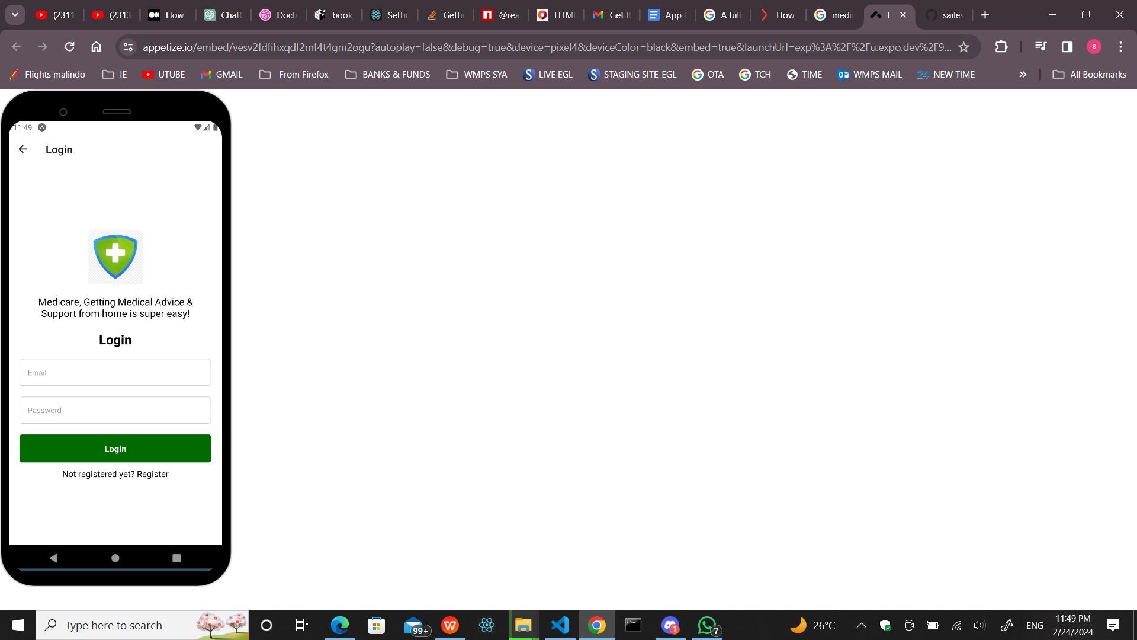

**Apps Name: Medicare:** Getting Medical advice & support from home is super easy!

**Objective:**

-With the help of a friendly online consultation app, you have access to many important like calendar integration, appointment scheduling, and finding the specialist doctor according to your need very easily and simply within a little amount of time.

**Apps Logo Creation:** 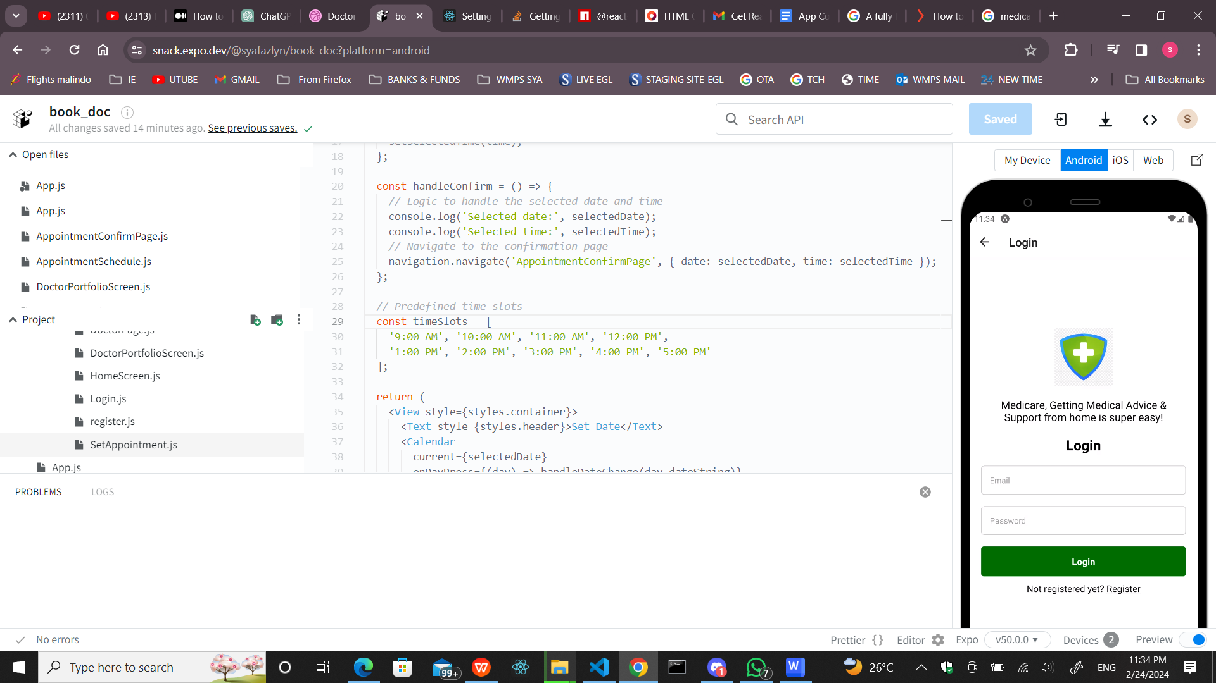

**Github:** <https://github.com/fazlynz/-health/tree/main/projecthealth>

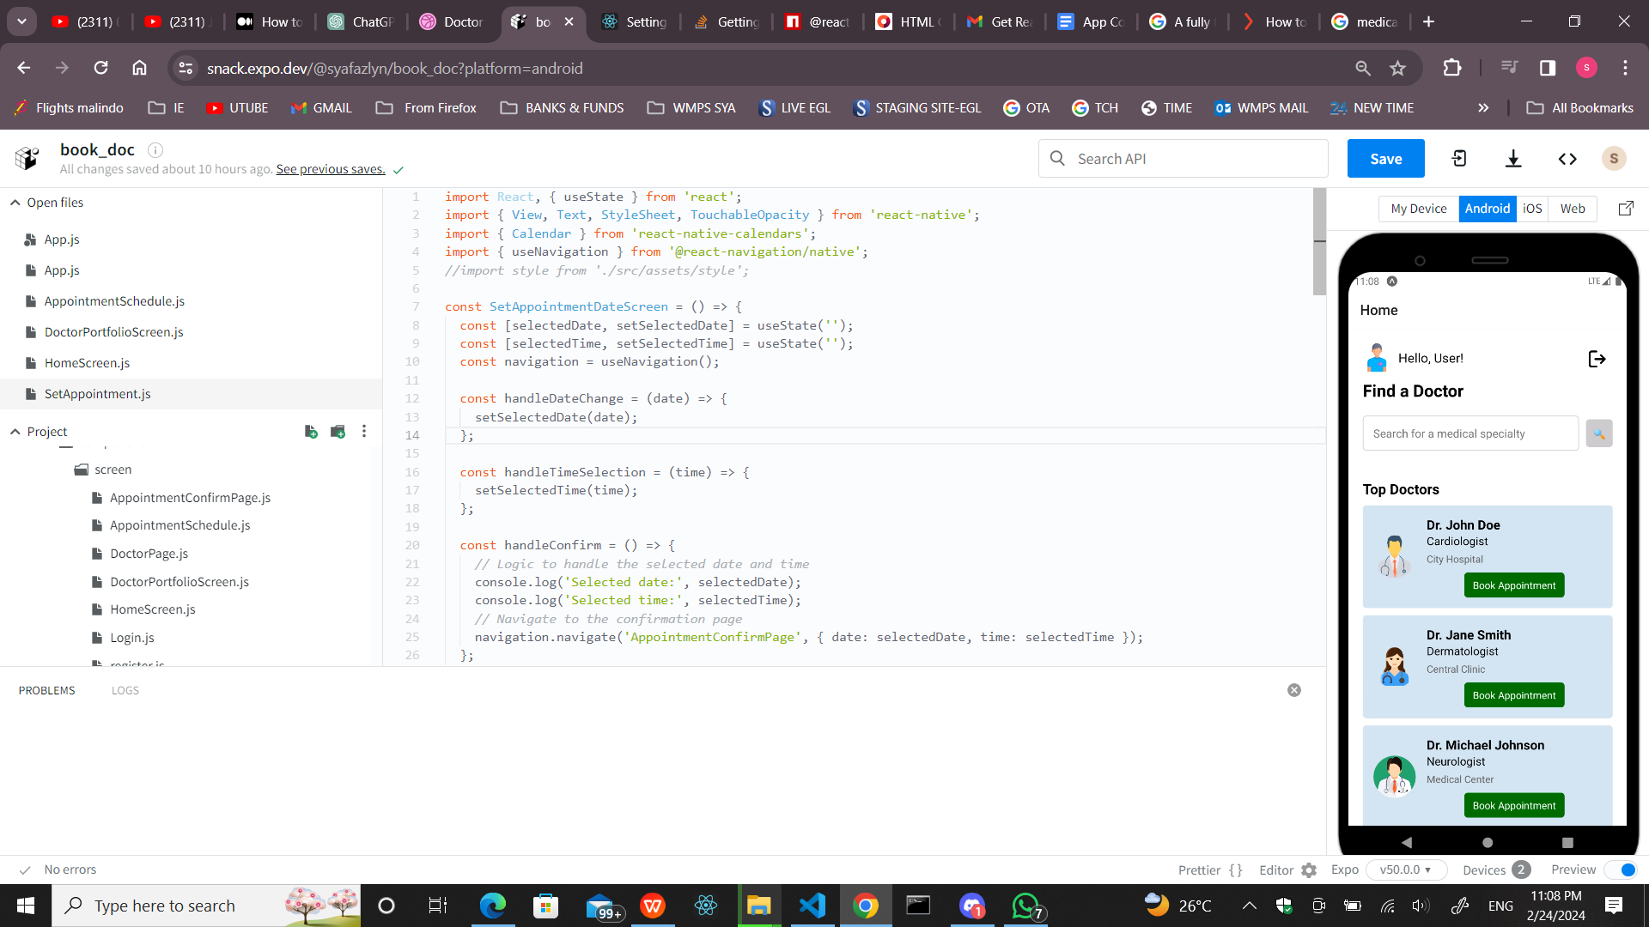

HomeScreen Display the user details, The logout button filtering searching by medical speciality and logout function. The log out function will lead to login page .

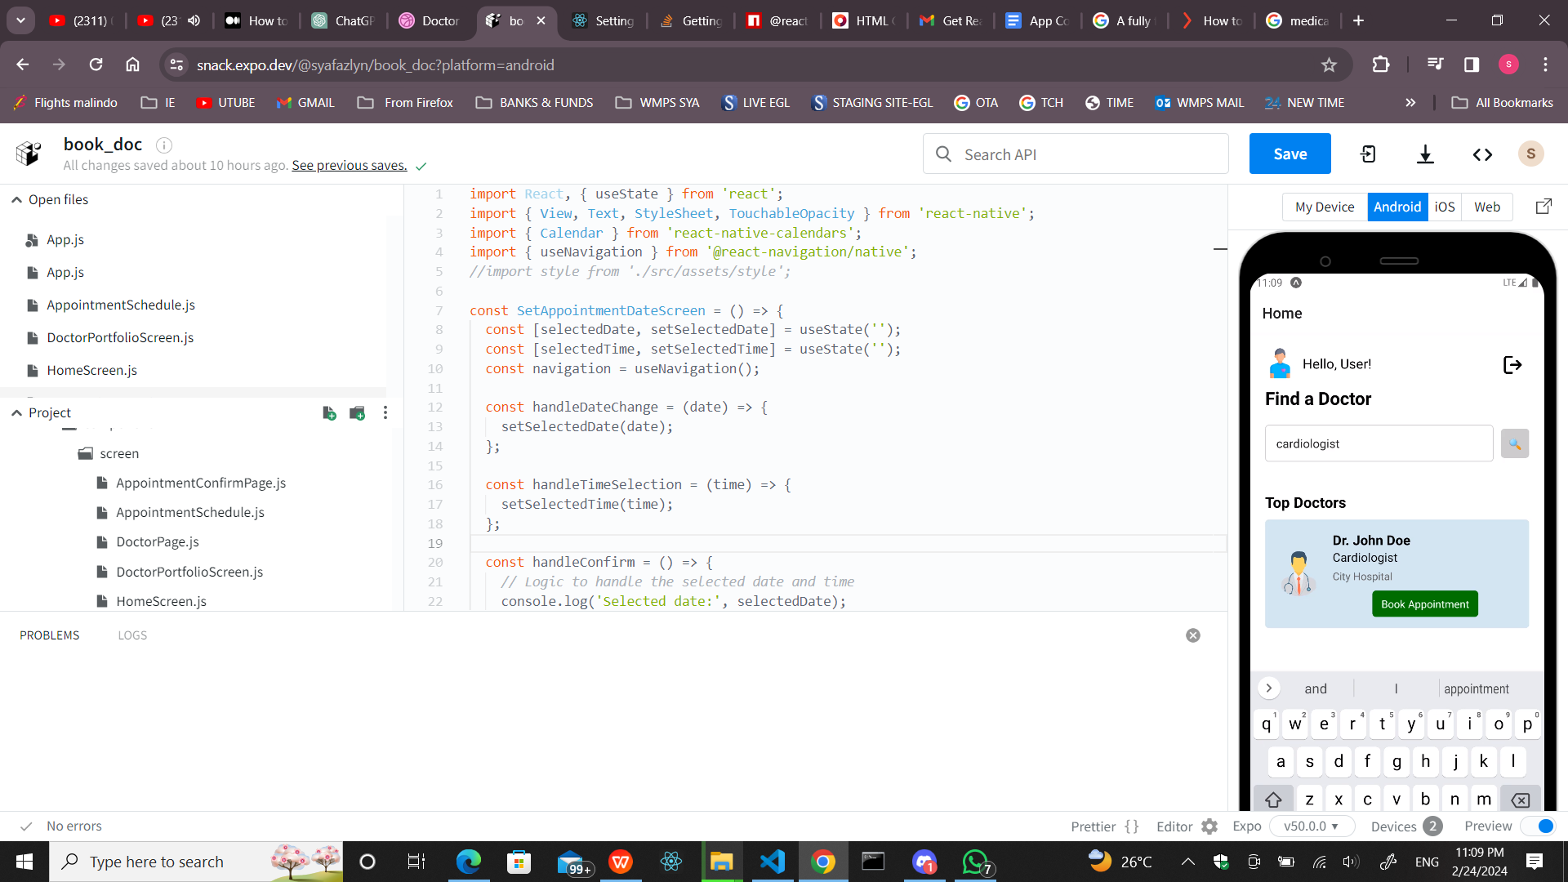

Home Screen : Be able to filter Doctor by speciality

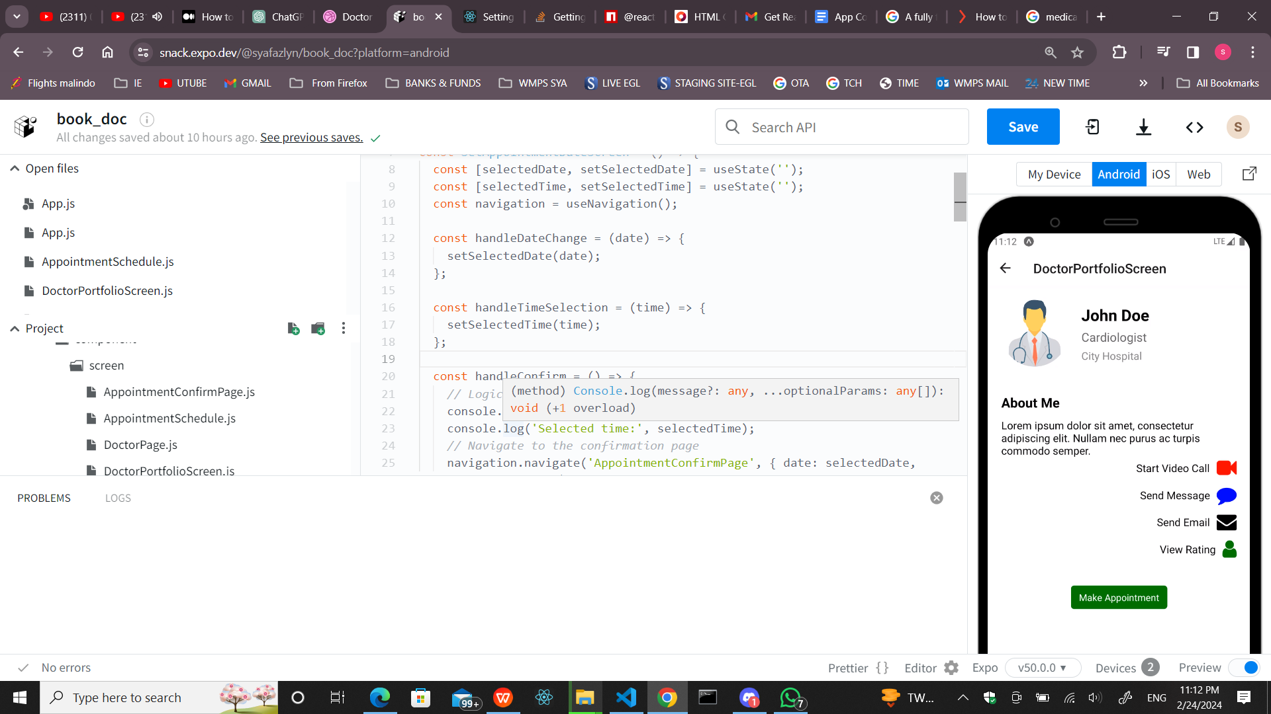

DoctorProfileScreen: To display the selected Doctor’s details and the Make appointment will direct to Set appointment screen ; which will allow user to set appointment by Date and Time.

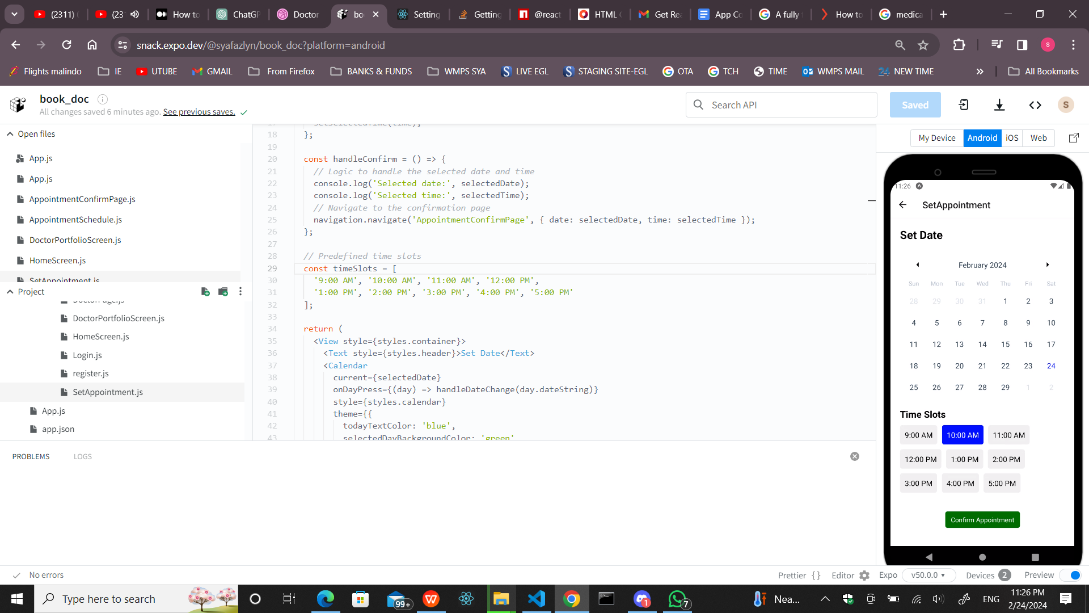

Set Appointment : To confirm appointment; Patient/user need to set date and Time slots

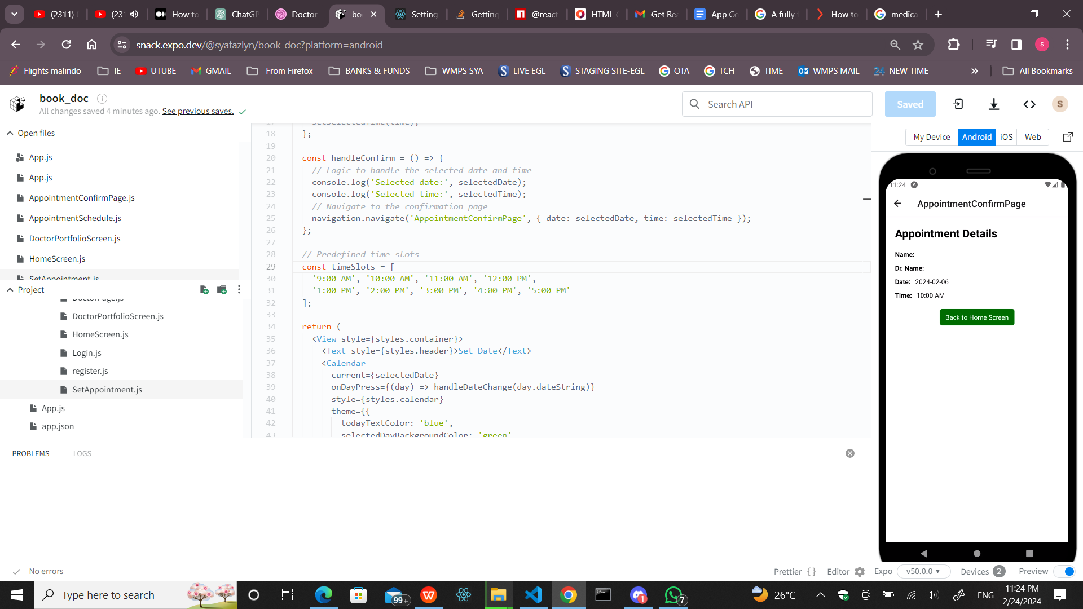

Appointment Confirm Screen: Showing Details of the appointment, The Back home screen function is applied to this screen, to allow user to make a new appointment if required.



Login Page: allow user to sign up

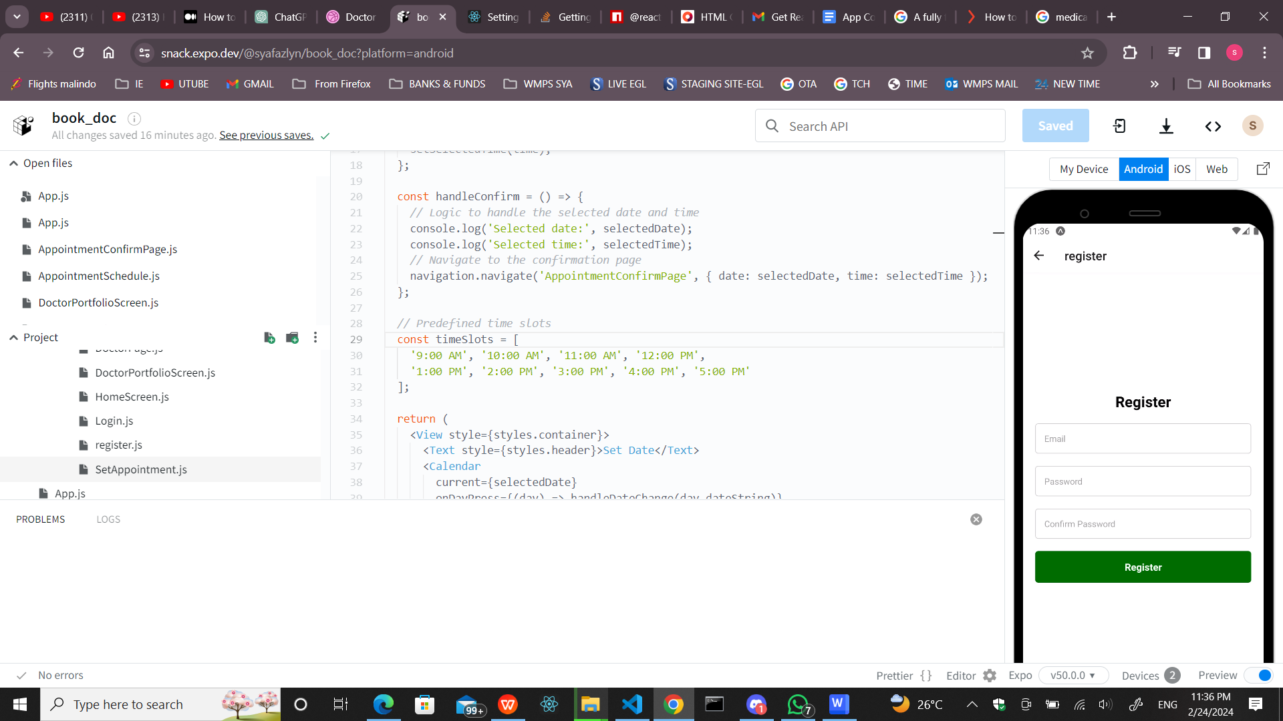

Register Page : To make new User Registration